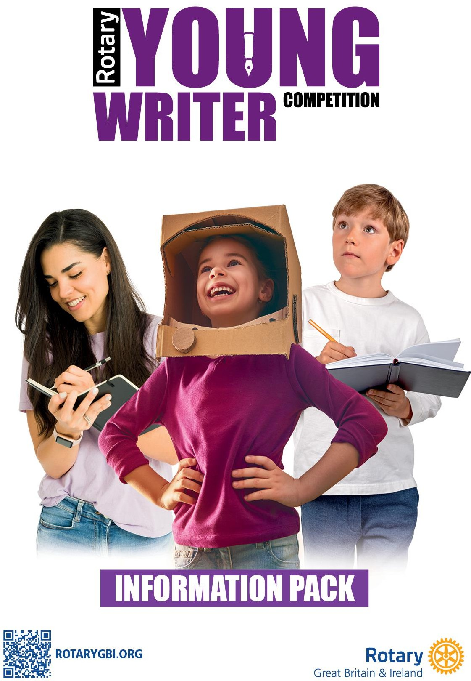

2025-26

Content:
Theme Page 3

Introduction Page 3

Aims and Objectives Page 3

Who Can Take Part? Page 3

How to Enter Page 3

Competition Guidelines Page 4
- Task
- Plagiarism or Close Copied Images
- Judges
- Judging Criteria
- Recognition

Rotary Youth Competitions and other opportunities for young people Page 4

Working with Children Page 4

Information Pack for 2025-26
THEME – ‘Happiness in Nature’
The ‘Happiness in Nature’ theme can be interpreted as broadly as the Young Writer wishes and does not need to conform to a
dictionary definition. Young people are encouraged to use their creativity to show what this theme means to them.
Introduction
The Rotary Young Writer competition is organised and promoted by Rotary International in Great Britain and Ireland (Rotary GB&I).
There are three stages to the competition, designed to support and encourage the development of writing skills. Some stages may include more than one round to select entrants progressing to the next stage.
Aims and Objectives
This competition aims to encourage young people to:

- develop their writing skills and creativity
- express their thoughts and ideas through the written word
- interpret the theme thoughtfully
- enjoy writing as a rewarding means of self-expression Who can take part?
The competition is open to all young people within the age groups shown below. They may be an individual choosing to enter directly themselves or amongst the entries submitted by a group or community organisation including schools and colleges, home educated, other young peoples’ community organisations, for example, community RotaKids or Interact, Scout Groups, Girl Guides, etc.
For entrants with motor control difficulties, an amanuensis may be used to record the entrant’s work to paper.

Age groups (based on age as of 31st August 2025):

Junior Up to and including 10 years old Intermediate 11 to 13 years old
Senior 14 to 17 years old

Note: Because the qualifying age is based on 31st August 2025, some entrants may have birthdays that would otherwise place them in a different age group at the actual date of the competition. For example, a young person who is 17 on 31st August but turns 18 on 3rd September 2025 is still eligible to enter as a Senior or a 10-year-old on 31st August 2025 with their birthday on 1st September 2025 is still eligible to enter the Junior category. Entrants must include their age on the entry form.
How to enter

To enter the Bulgarian competition, please email the Rotary GB&I and Bulgaria Team at gergana.georgieva@rotary-bourgas.org.
Entrants should submit their entry individually. A completed entry form and a digital copy of the written piece must be submitted to gergana.georgieva@rotary-bourgas.org by January 15th 2026.

Competition Guidelines
Task
To produce a handwritten or typed story in prose or poem entitled ‘Happiness in Nature’. The written entry could be fiction or non- fiction, as long as the piece relates to the theme and all entries must be legible.
Please note:
- Prose entries should be up to a maximum 550 words
- Poetry entries should be up to a maximum of 40 lines
And entries that exceed these maximum numbers will be disqualified.
- No pictures and/or drawings are to be part of the entry.
Entries may not be returned unless specifically requested.

Plagiarism or Close Copied Images
Plagiarised or 'close-copied' images are not permitted in any competition. It is important that we protect the work of creative individuals. Whilst we are all inspired by the work of others, there is without doubt a grey area where inspiration carries over to close copying. For our competitions 'close copying' is where, to a reasonable person, the submitted entry appears remarkably similar in significant important respects to a body of work created elsewhere. We are looking for original pieces, not copies, which match the theme of the competition. Competitors must not use any apps which produce any part of their submission, if detected the entry will be disqualified.

Judges
The judges will be people with appropriate skills appointed by the organisers accordingly.

At the National level the judges will be appointed by Rotary GB&I and will not be Rotarians.
Judging Criteria
Judges will consider:
- imagination relative to the subject
- the ability to engage interest
- the ability to be consistent in the power of argument
- relevance to the theme.
The judges will not enter any discussion or correspondence regarding their decision; the decision of the judges will be final and not subject to any appeal.

Recognition
At all stages of the competition, competitors will receive a Certificate of Participation.
Rotary Youth Competitions and other opportunities for young people

Take a look at https://www.rotarygbi.org/projects/young-people/ to explore
- other Rotary Youth Competitions: Artist, Chef, Environmentalist, Musician, Photographer, Youth Speaks and Youth Speaks A Debate
and
- Rotary Young Citizen Awards, Rotary Young Citizen Environmentalist Award, Rotary Young Citizen Peacemaker Award and Rotary Young Citizen Sporting Hero Awad
You may wish to enter more than one competition or Award.

You’ll also find information about
- Rotary Technology Tournaments which are organised in many areas
- Rotary programmes including RotaKids, Interact, and Developing Future Leaders
- Rotary Youth Exchange and more
There may be additional opportunities available locally - connect with Rotarians in your area to find out what’s happening near
you.
Working with Children
Rotary GB&I has adopted this statement of policy in working with children, vulnerable adults and those with disability:
The needs and rights of the child, the elderly, the vulnerable and those with disability take priority. It is the duty of every Rotarian to safeguard to the best of their ability, the welfare of and prevent the physical, sexual or emotional abuse and neglect of all children, the elderly, persons with disability or otherwise vulnerable persons with whom they come into contact during their Rotarian duties.
Click here to see the Rotary GB&I Safeguarding Policy

