Your Benefits of using My Rotary
once you have registered on Rotary’s website www.rotary.org

 |  |  |  | 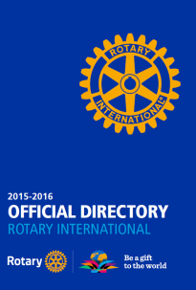  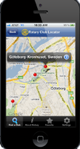  a
Lead a discussion with other members of the family of Rotary using Discussion Groups. |  | Read all about other clubs’ projects – planned and on-going projects via  Rotary Ideas; and completed projects via Rotary Showcase. |  | Find clubs via Club Finder and their contact details from the online Official Directory.
 |  |  |  | 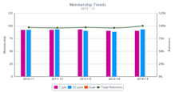
Create a new logo for your club. The Brand Center offers more information on Rotary’s new visual identity (templates, policy). |  | Download Rotary publications free from the Document Center and subscribe to Rotary newsletters. |  | Learn more about your own Club and Rotary worldwide from Rotary Club Central.

Register – Log in – Learn more

Discover the benefits of My Rotary.

Questions? – Find help from our FAQs.

